**DAILY ONLINE ACTIVITIES SUMMARY**

|  |  |  |  |  |  |  |  |  |
| --- | --- | --- | --- | --- | --- | --- | --- | --- |
| **Date:** | **06/06/2020** | | | | | **Name:** | **POOJA D S** | |
| **Sem & Sec** | **4th SEM 'B' Section** | | | | | **USN:** | **4AL18CS056** | |
| **Online Test Summary** | | | | | | | | |
| **Subject** | | **Data Communication** | | | | | | |
| **Max. Marks** | | **30** | | **Score** | | | **27** | |
| **Certification Course Summary** | | | | | | | | |
| **Course** | **Computer vision Essentials** | | | | | | | |
| **Certificate Provider** | | | **Great Learning Academy** | | **Duration** | | | **5.5 hour** |
| **Coding Challenges** | | | | | | | | |
| **Problem Statement:** A user will input two strings, and we find if one of the strings is a sub sequence of the other. Program prints “yes” if either the first string is a sub sequence of the second string or the second string is a sub sequence of the first string. Assume that, the length of the first string is smaller than or equal to the length of the second string. Assume that, the length of the first string is smaller than or equal to the length of the second string. | | | | | | | | |
| **Status: completed** | | | | | | | | |
| **Uploaded the report in Github** | | | | | **yes** | | | |
| **If yes Repository name** | | | | | <https://github.com/dspooja/Java-coding>  <https://github.com/dspooja/C-coding> | | | |
| **Uploaded the report in slack** | | | | | **yes** | | | |

Online Test Details: (Attach the snapshot and briefly write the report for the same)

Certification Course Details: (Attach the snapshot and briefly write the report for the same)

Coding Challenges Details: (Attach the snapshot and briefly write the report for the same)

ONLINE TEST DETAILS:

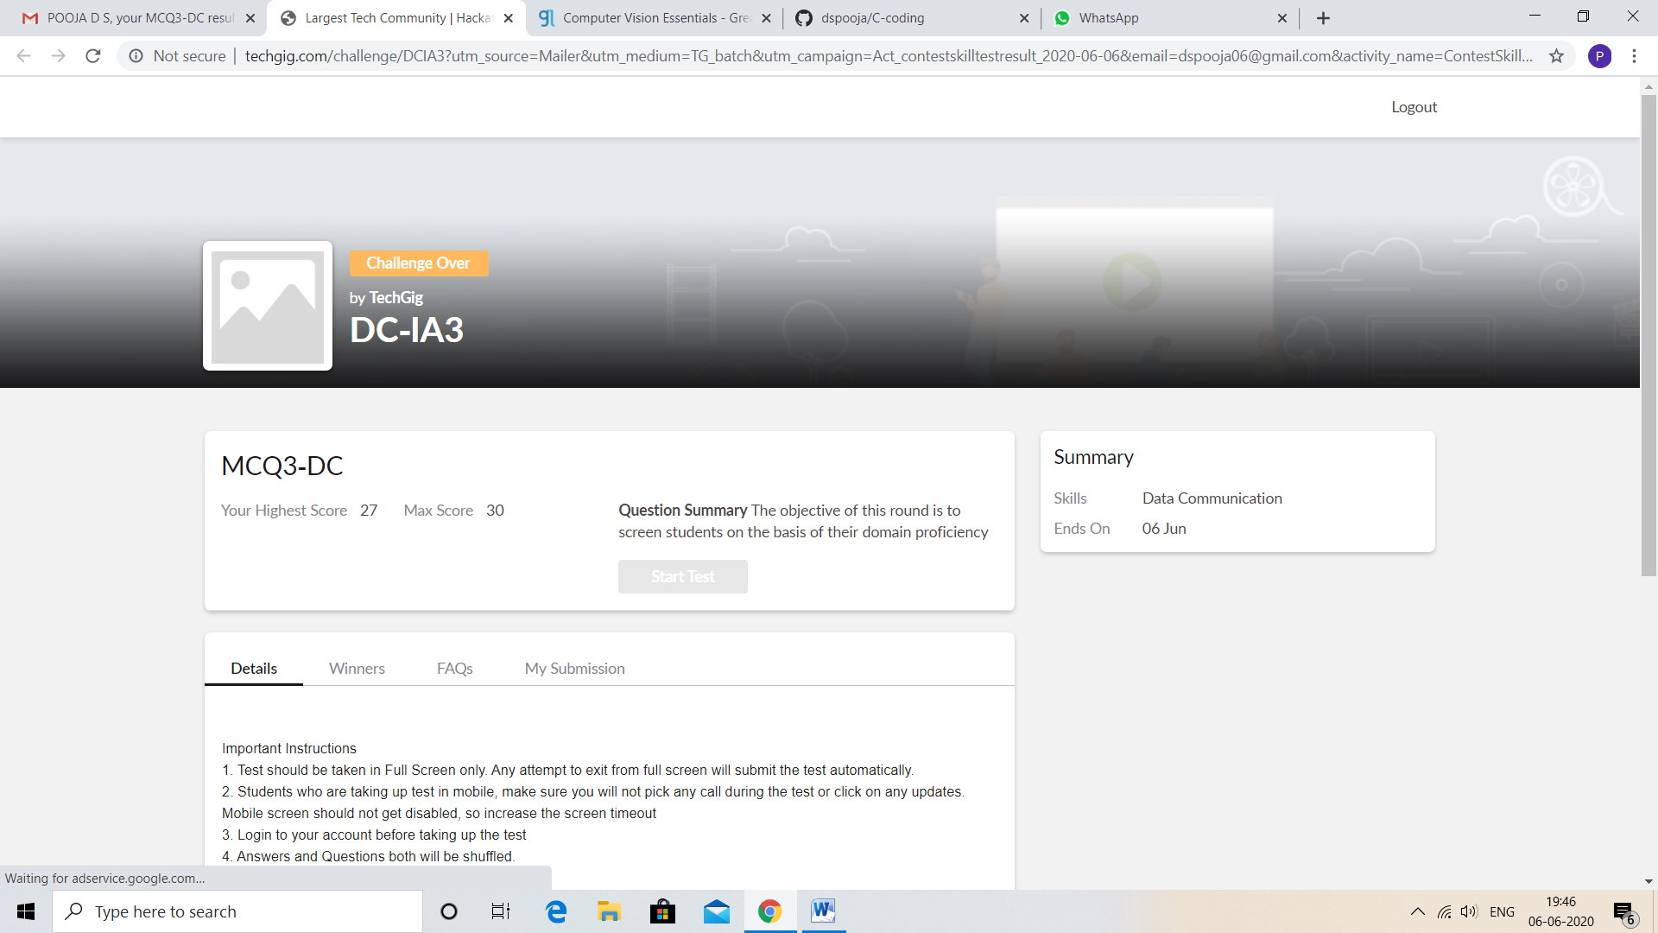

CERTIFICATION COURSE DETAILS:

* As continuation of the **Computer vision Essentials** online course**.**
* **The concepts covered in Computer vision Essentials are:**
* Visualization (run pacakge, occlusion experiment)
* Hands on demo –T-SNE

And I Attend quiz based on this course.

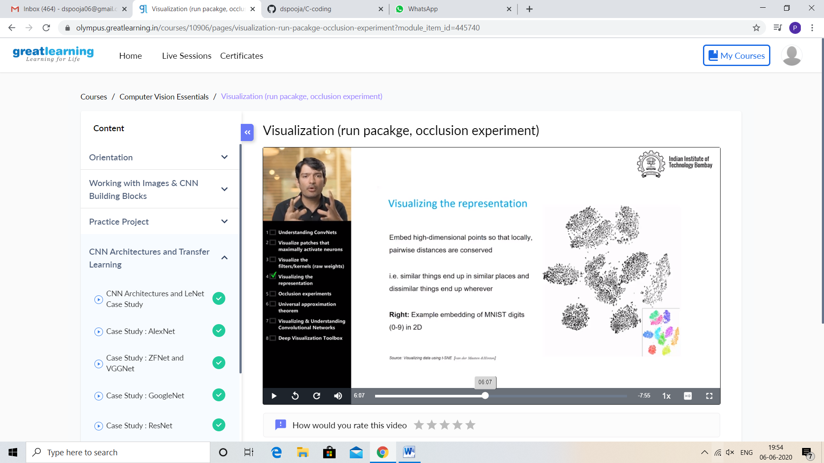

CODING CHALLENGES DETAILS:

Problem statement 1:

Write a Java Program

Given an array A of size N containing 0s, 1s, and 2s; you need to sort the array in ascending order.  
Input:  
The first line contains an integer 'T' denoting the total number of test cases. Then T testcases follow. Each testcases contains two lines of input. The first line denotes the size of the array N. The second lines contains the elements of the array A separated by spaces.

Output:  
For each testcase, print the sorted array.

Constraints:   
1 <= T <= 500  
1 <= N <= 106  
0 <= Ai <= 2

Example:   
Input :  
2  
5  
0 2 1 2 0  
3  
0 1 0

Output:   
0 0 1 2 2  
0 0 1

Solution: Uploaded it in github

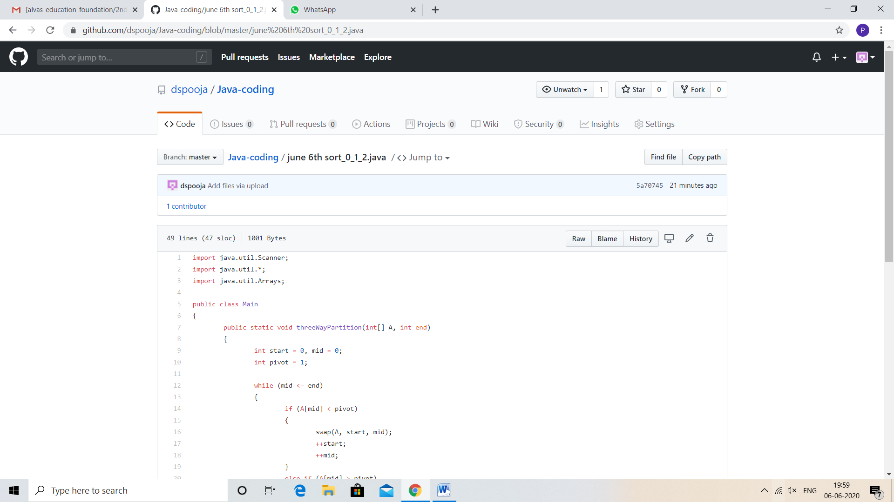

Problem statement 2:

Write a program in C to rotate an array by N positions.

**Expected Output:**   
**The given array is:** 0 3 6 9 12 14 18 20 22 25 27  
Enter the Position N from where you want to rotate: 4  
From 4th position the values of the array are: 12 14 18 20 22 25 27  
Before 4th position the values of the array are : 0 3 6 9  
After rotating from 4th position the array is:  
12 14 18 20 22 25 27 0 3 6 9

Solution: Uploaded in github.

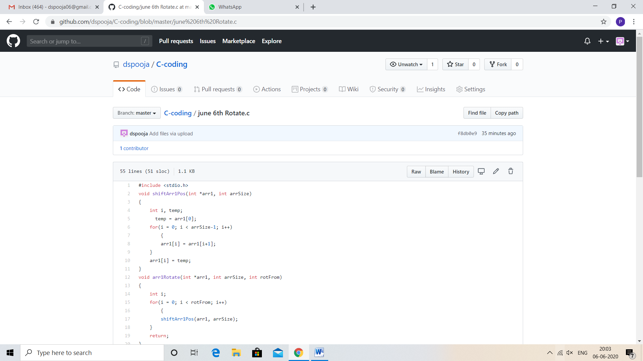

Problem statement 3:

Write a Java Program to find the second-highest number in an array.

Solution: Uploaded in github.

